# Project Report on Study Management System

## Course Title: Project

Course Code : CSE 3200

Date of submission: 17/10/2023

|  |  |
| --- | --- |
| **Submitted by**  Name : Sharif Hasan  Roll : 190123  Session: 2018-2019  Department of Computer Science and Engineering  Pabna University of Science and Technology | **Submitted to,**  Dr. Md. Abdur Rahim,  Associate Professor,  Departmnet of Computer Science and Engineering  Pabna University of Science and Technology |

## Declaration

I am **Sharif Hasan** declare that this project report is my own original work and has never

been presented to any institution of higher learning for the award of Bachelor of

Pabna University of Science and Technology.

**Sharif Hasan**

Signature

……………………………..

## Approval

This graduation Project Report has been submitted with the approval and

supervision Of: ___________________

Department Of Computer and Engineering

Pabna University of Science and Technology

**Abstract**

The Study Management System is a web-based application developed to help students manage their study materials, classes, and track their academic progress. This project utilizes the Laravel 10 framework for the backend and Vue.js for the frontend. The application also incorporates a token-based payment system and provides statistical insights through graphs and charts. The system is built on PHP 8 and aims to enhance the academic experience for students.

**Background Study**

Before starting work on this project, I have analyzed there is almost no dedicated project regarding solving this problem. So, students often mix up their study materials and fall into problem before their examination arive.

**Existing physical system**

As there are no dedicated existing system, students often have to manage their materials manually using file systems or messenger. But it is not efficient. Also, this type of management provide no guarantee and often mixes up what is important and not important.

**My proposed system**

My proposed system to solve this issue is to create a dedicated system where students creates their own account and put all their study related digital material in one place class wise. Hence when they need them, they can get it from a single place all formated. Also here they can study and get insights on their study times to help them be more focused.

**Project Objectives**

The primary objectives of this project are as follows:

1. **Study Material Management**: Provide a platform for students to organize and manage their study materials, including notes, documents, and multimedia resources.
2. **Payment System**: Implement a token-based payment system that allows students to access premium features or content.
3. **Statistical Insights**: Provide visualizations and statistics to help students assess their academic progress and performance.

**System Architecture**

The Study Management System is built using the following technologies:

* **Backend Framework**: Laravel 10
* **Frontend Framework**: Vue.js
* **Database**: MySQL
* **Server**: Apache
* **Programming Language**: PHP 8
* **Token-Based Payment System**: Custom implementation using Laravel's built-in tools
* **Graphs and Charts**: JavaScript libraries (e.g., Chart.js) for data visualization

**Features and Functionalities**

**Study Material Management**

* **Upload and Organize**: Users can upload study materials and organize them into folders or categories.
* **Search and Filter**: Implement a search and filter functionality to help users quickly find the materials they need.
* **Annotations**: Allow users to add notes or annotations to study materials for personal reference.

**Token-Based Payment System**

* **Token Generation**: Users can purchase tokens using various payment methods.
* **Premium Access**: Certain features or content are locked and can be unlocked using tokens.

**Statistical Insights**

* **Performance Metrics**: Provide insights into academic performance, such as GPA, attendance, and assignments.
* **Visualizations**: Display charts and graphs to help users visualize their progress.

**Development Process**

The project development followed the Agile methodology, which involves iterative development with regular feedback from users. The team consisted of backend and frontend developers, designers, and quality assurance testers. The process can be summarized as follows:

1. **Project Planning**: Define the project scope, objectives, and requirements.
2. **Architecture and Database Design**: Design the system's architecture, database schema, and API endpoints.
3. **Development**: Implement the frontend and backend components, including user authentication, material management, class scheduling, payment system, and statistics generation.
4. **Testing**: Conduct rigorous testing to identify and fix bugs and issues.
5. **Deployment**: Deploy the application to a production server and ensure its stability and performance.
6. **User Acceptance Testing**: Gather feedback from users and make necessary improvements.
7. **Documentation**: Prepare user manuals and technical documentation.

**Screenshoots**

**Home Page**

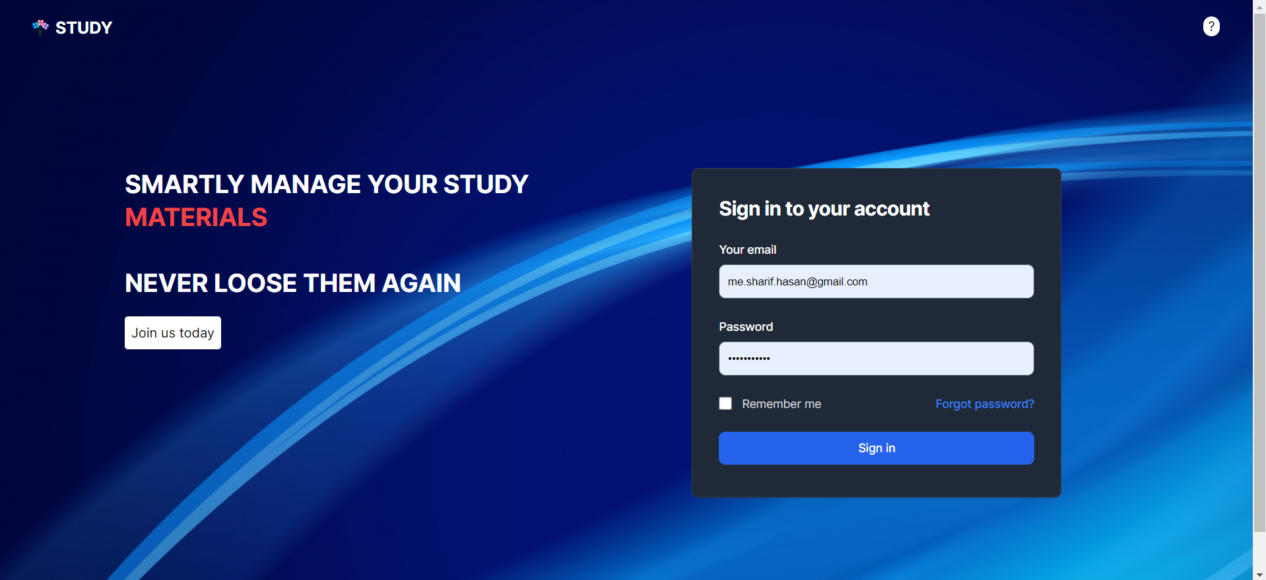

**Dashboard**

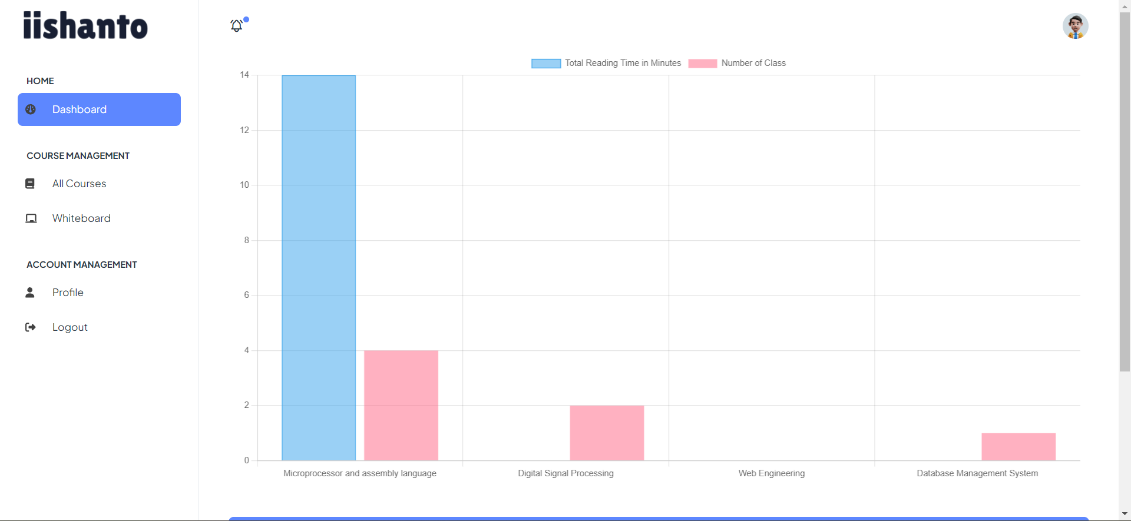

**Courses Page**

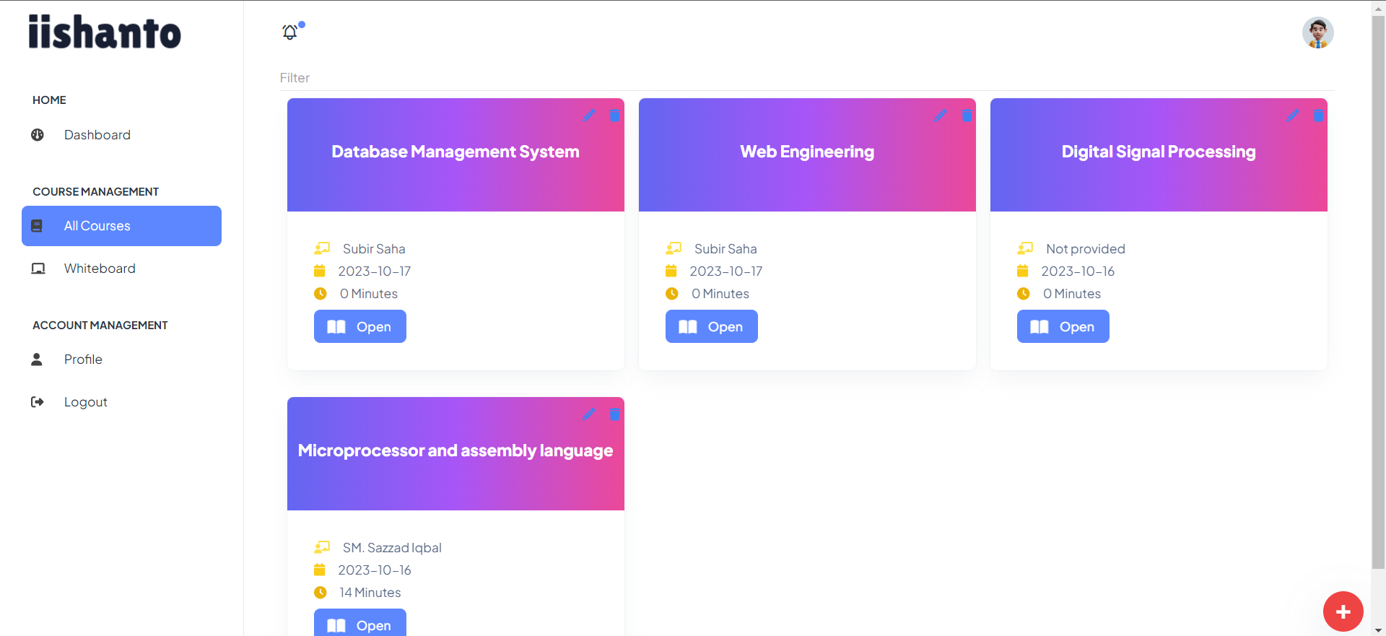

**Resources Page**

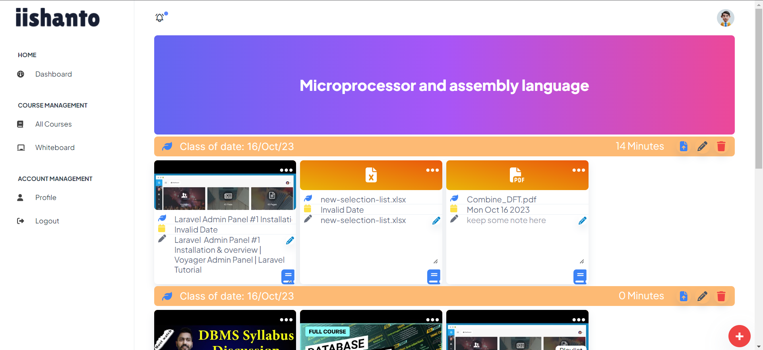

**Whiteboard Page**

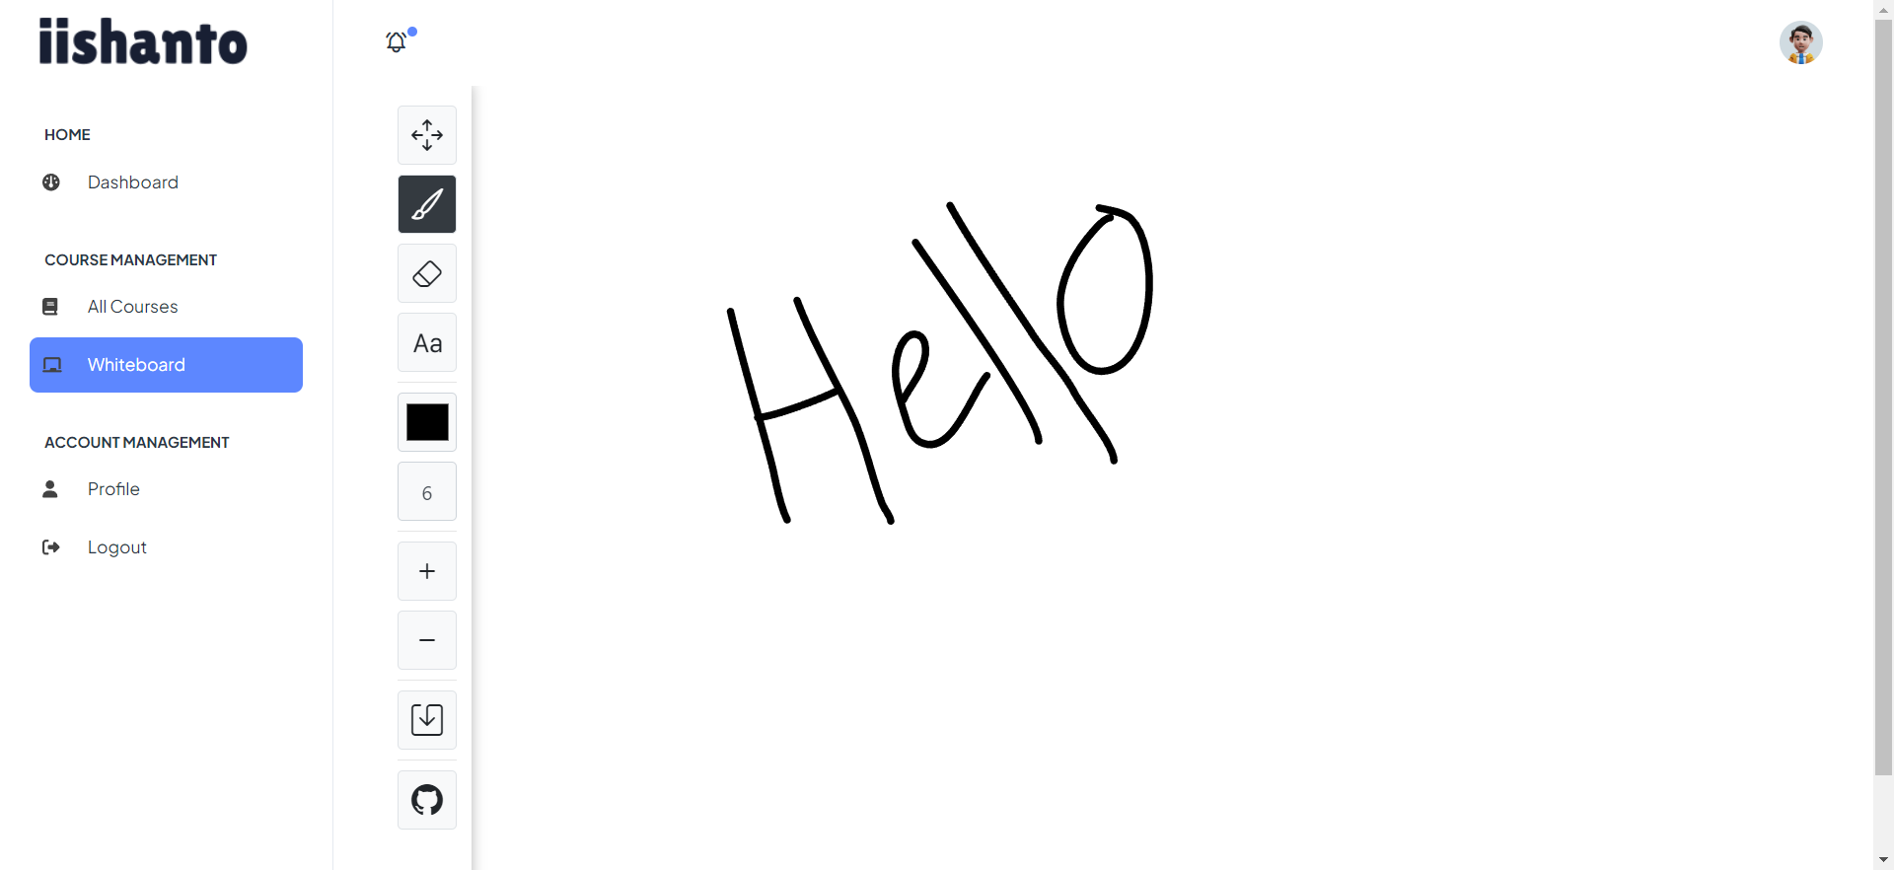

**Profile Page**

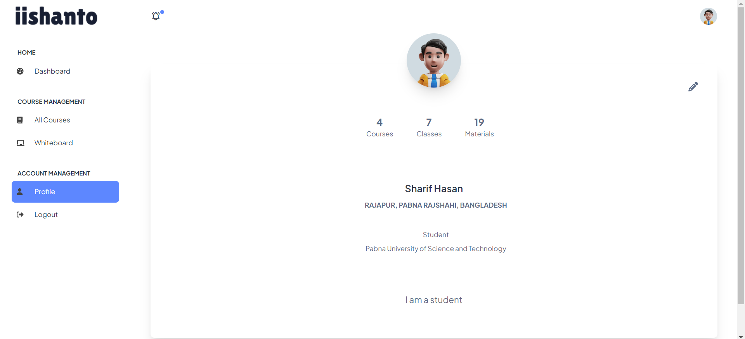

**Conclusion**

The Study Management System is designed to streamline students' academic lives by providing tools for material management, class scheduling, and performance tracking. The inclusion of a token-based payment system allows for monetization, while the statistical insights give users valuable feedback on their progress. This project represents a significant step forward in enhancing the educational experience and supporting student success.

**Future Enhancements**

* Integration with popular learning management systems (LMS) for easier access to course materials.
* Mobile application development to provide a more accessible and convenient platform for users.
* Enhanced collaboration features to support group study sessions.
* Integration with third-party APIs for real-time updates on assignments and deadlines.
* User feedback and feature requests will continue to guide future development efforts.

This project aims to be an ongoing endeavor that adapts to the evolving needs of students and the educational environment.